Visiting Northern Ireland
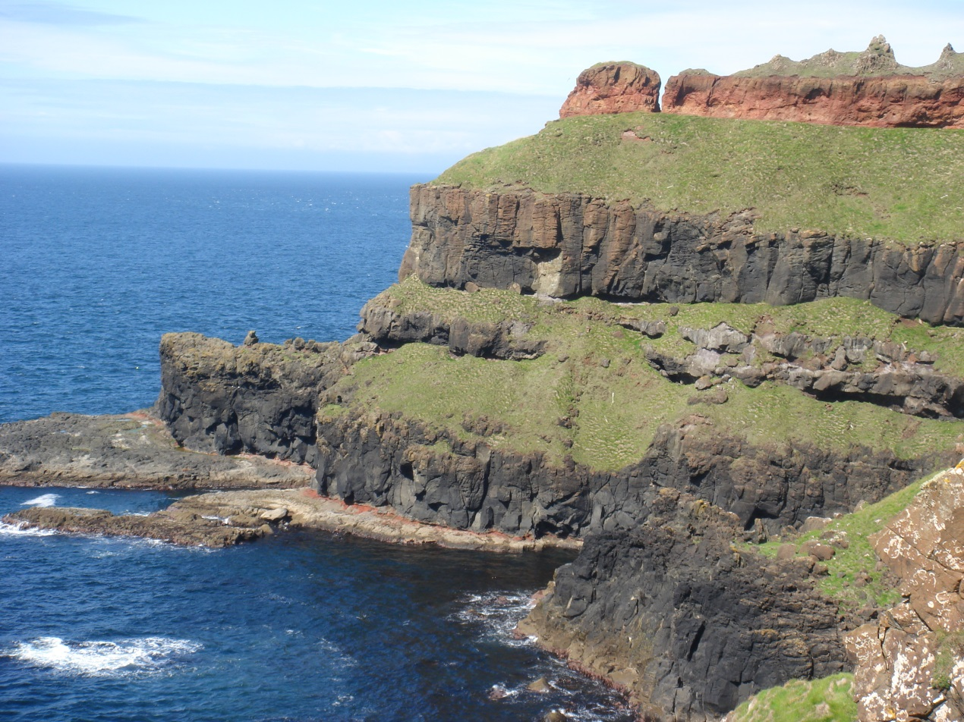
Choose one of the following exercises to be completed by next week
Exercise 1:
Follow the link of Northern Ireland in the first paragraph and prepare a 5 minute presentation of its history.
Exercise 2:
Imagine you went on a one-week trip to Northern Ireland. Write an email (120-150 words) to your best friend describing your experience.
Exercise 3:
Research the most famous people that come from Northern Ireland. Choose two and write a short biography to be presented in class.

